CS 255 System Design Document

System Components and Design

Purpose
What is the purpose of this project? Who is the client and what do they want their system to be able to do?
- The company DriverPass wants a system for students to study, practice, and test themselves on driving-related material to better prepare themselves for their driving test.
- In addition to the online access to classes and practice tests, they also want to provide the option to schedule on-the-road training with a teacher and allow the students to be able to download material onto their device to review/practice offline.

System Background
What does DriverPass want the system to do? What is the problem they want to fix? What are the different components needed for this system?
- DiverPass has noticed that a lot of students are failing their driving tests because they’re unprepared for them, so they want to provide a service that allows them to study and practice at their convenience so that they can be prepared for and pass their driving test.
- Users should be able to make and cancel reservations for on-the-road training/driving lessons for the following available packages:
  - Package One: Six hours of on-the-road training (split into three two-hour sessions).
  - Package Two: Eight hours of on-the-road training (split into four two-hour sessions) as well as an in-person lesson discussing DMV rules and policies.
  - Package Three: Twelve hours of on-the-road training (split into six two-hour sessions), an in-person lesson explaining DMV rules and policies, and access to the online classes and test materials.
    - Users should be able to study online and download study material for offline use.
- During registration in the program, the user provides their personal information (first name, last name, address, phone number, state, and credit card information), their pick-up and drop-off information for the driving lessons, and establishes a username and password for their account.
- The DriverPass system needs to be linked to the DMV’s requirements and policies for driving tests so that the class and test information is up-to-date and compliant.

Objectives and Goals
What should this system be able to do when it is completed? What measurable tasks need to be included in the system design to achieve this?
- Students should be able to access their data whether online or offline but only modify their data while online to prevent data duplication.
- The system will run online via a cloud system that will handle backup and security for them.
- The user interface will match the sketch given to us by DriverPass, with the company logo at the top of the page and two columns with the user’s online test progress and their driver’s notes on the left side and the user’s personal information, any special needs, and their driver and student photos on the right.
- Only DriverPass IT should have access to the accounts for security purposes and be able to track when a user changes their information or record in the system.
- Users should be able to make and cancel reservations for on-the-road training/driving lessons.
  - Reservations can be made and changed online, by phone call, or in-office.
  - Each reservation is for a two-hour lesson.
  - The user needs to determine the day and time of the lesson at the time of making the reservation.
  - DriverPass should be able to access the driver and car information for each reservation to track which user is matched with which driver, which car, and for what date/time.
- To start, DriverPass wants there to be three packages available for the user to choose from, but they want the flexibility to be able to disable a package if they don’t want more users registering for it.
- During registration in the program, the user provides their personal information (first name, last name, address, phone number, state, and credit card information), their pick-up and drop-off information for the driving lessons, and establishes a username and password for their account.
  - The user should be able to do this registration process online, on the phone, or in person with the DriverPass secretary.
- If the user forgets their password, they should be able to safely reset it.
- The DriverPass system needs to be linked to the DMV’s requirements and policies for driving tests so that the class and test information is up-to-date and compliant, and there should be a notification whenever the DMV updates that information.

Requirements

Nonfunctional Requirements
In this section, you will detail the different nonfunctional requirements for the DriverPass system. You will need to think about the different things that the system needs to function properly.

Performance Requirements
What environments (web-based, application, etc.) does this system need to run in? How fast should the system run? How often should the system be updated?
- This will be a web-based application, but users will be given the option to download practice tests and coursework that they can do offline.
- The system should be fast enough to be able to keep real-time updates to scheduling changes for on-the-road or in-person lessons.
- The system should be updated in real-time for registration and scheduling on-the-road training and in-person lessons.
- Updates on the online classes and practice tests should be updated periodically based on any changes made to DMV protocol and requirements, which the DMV will send notifications of any changes made to their policies.

Platform Constraints
What platforms (Windows, Unix, etc.) should the system run on? Does the back end require any tools, such as a database, to support this application?
- The system will run off a web-based cloud platform.
- A database would be helpful for a backend tool to track user account information, course completion, and reservations.

Accuracy and Precision
How will you distinguish between different users? Is the input case-sensitive? When should the system inform the admin of a problem?
- Each user will have a unique username that will be used to distinguish between different users.
- The input should be case-sensitive in order to make input validation easier and the usernames and passwords more secure.
- The system will send updates to the admin whenever a new reservation is made, modified, and canceled and who performed each of those actions.

Adaptability
Can you make changes to the user (add/remove/modify) without changing code? How will the system adapt to platform updates? What type of access does the IT admin need?
- Changes to user information will be able to be made without changing code, but adding or removing Package modules will need to be coded into the system by a developer.
- The IT admin needs to have full access to all the accounts in the system so that he can perform necessary actions like resetting a password if a user forgets it or blocking a user’s account if they de-register from the program.

Security
What is required for the user to log in? How can you secure the connection or the data exchange between the client and the server? What should happen to the account if there is a “brute force” hacking attempt? What happens if the user forgets their password?
- The user needs to register with a username and password, which they can use to login to their account on the app.
- In order to secure the connection and data transfers between the client and server, data can’t be changed or updated when the user is offline. Users can still download practice tests and course information to do offline, but they won’t be able to change their account info or schedule/reschedule classes unless they’re online.
- If someone forgets their password, they can request to reset it, and that request will be handled through the DriverPass IT admin.

Functional Requirements
Using the information from the scenario, think about the different functions the system needs to provide. Each of your bullets should start with “The system shall . . .” For example, one functional requirement might be, “The system shall validate user credentials when logging in.”
- The system shall register each user with a unique username and secure password.
- The system shall validate user credentials when logging in.
- The system shall have complete access to content when connected to the internet and offer the option to download coursework and practice tests for users to review offline.
- The system shall run online through a cloud-based platform.
- The system shall allow updates and modifications when online.
- The system shall track whenever a reservation is made, modified, or cancelled.
- The system shall hold the information of each reservation, including the user information who made it (name, phone number, address, state, and credit card information), which trainer is scheduled for that on-the-road or in-person lesson, the scheduled time. Additionally, for on-the-road lessons specifically, each reservation information will include the car the trainer is using (for on-the-road lessons) as well as the pickup and drop-off location chosen by the user.
- The system shall allow admin to disable one or more of the available Packages offered to users as needed.
- The system shall

User Interface
What are the needs of the interface? Who are the different users for this interface? What will each user need to be able to do through the interface? How will the user interact with the interface (mobile, browser, etc.)?
- The User Interface should be laid out with the company logo at the top of the page, then the rest of the page split into two columns.
  - On the left will be the user’s online test progress and Driver Notes. The test progress section will show the tests the user has taken and their scores (“Not Taken”, “In Progress”, “Failed”, or “Passed”). The Driver Notes section will contain any comments and feedback left by their Driver during on-the-road lessons as well as the information for each of their on-the-road sessions (time scheduled, time started, and time ended).
  - On the right side of the page will be the user’s personal information (name, phone number, address, email, etc.), any special needs they have (i.e. dyslexia), a photo of their Driver and a photo of the user.
- When connected to the internet, the user should be able to access and update their personal information, take online tests and check their scores, review their Driver notes/feedback, and download coursework or tests to take while offline.
- Users should be able to access and interact with the User Interface the same way whether they’re on their mobile device or on a computer.

Assumptions
What things were not specifically addressed in your design above? What assumptions are you making in your design about the users or the technology they have?
- For this system, we’re assuming that users have access to either a mobile device or computer to use the app.
- For this system, we’re assuming that the users have internet access to use the app.
- For this system, we’re assuming that users have access to a phone to be able to call the office or the ability to physically go to the office to make or cancel training reservations.

Limitations
Any system you build will naturally have limitations. What limitations do you see in your system design? What limitations do you have as far as resources, time, budget, or technology?
- For this system design, we’re limited to providing the Packages set by the client. The client will be able to disable Packages and block users from registering for them, but at this time, they won’t be able to add or remove Packages.
- DriverPass is limited to 10 cars and one Driver/Trainer per car for on-the-road lessons.
- DriverPass is a smaller company, so they’re relying on a cloud-based platform to provide backup and security services for the app.
- For this system design, we’re limited to the 4-month schedule established in the following Gantt Chart.

Gantt Chart
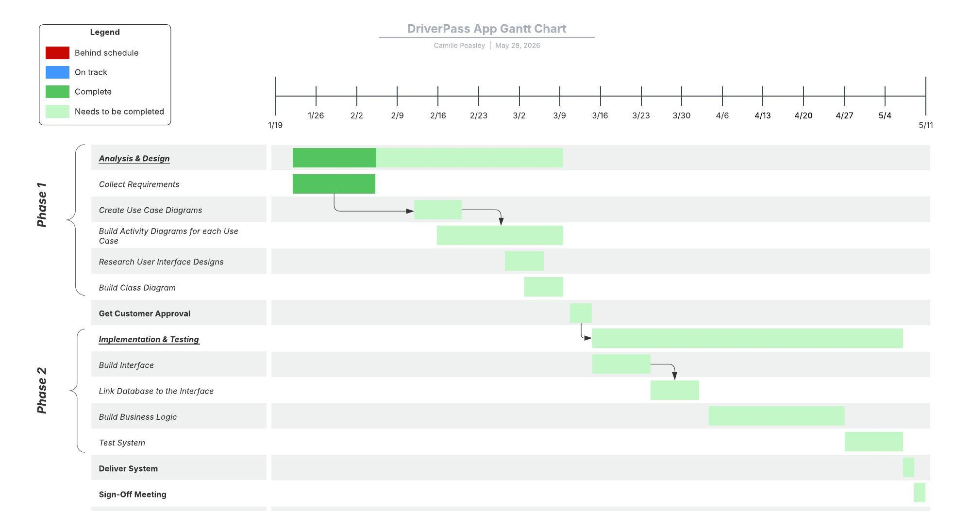

UML Use Cases Diagram
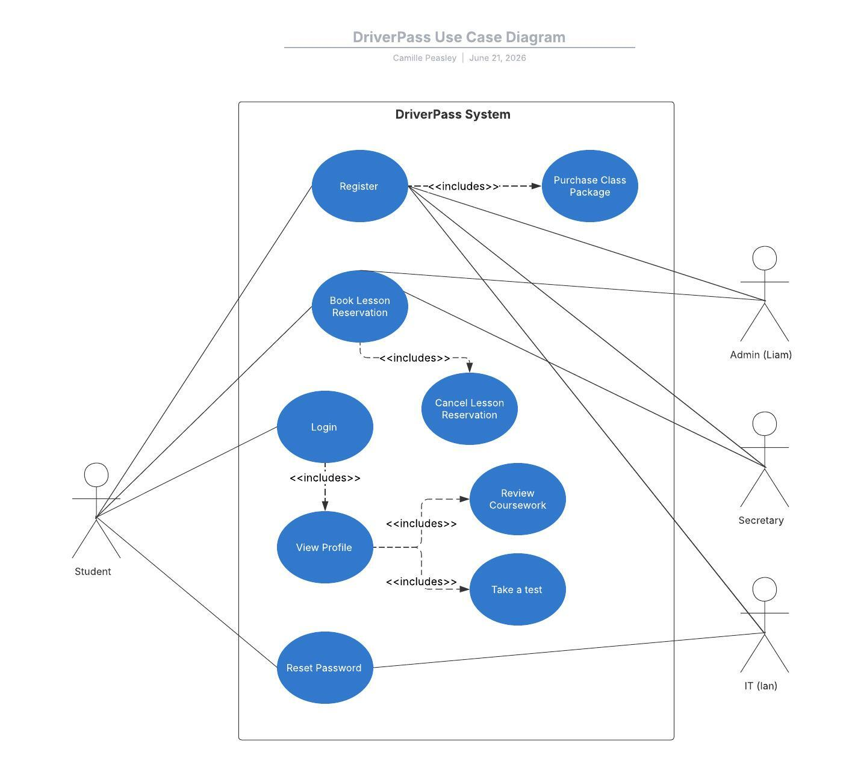

UML Activity Diagrams

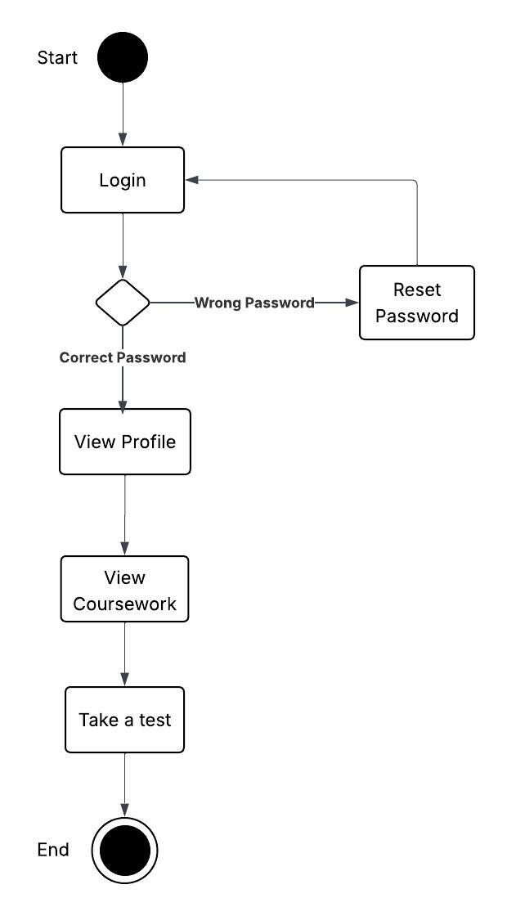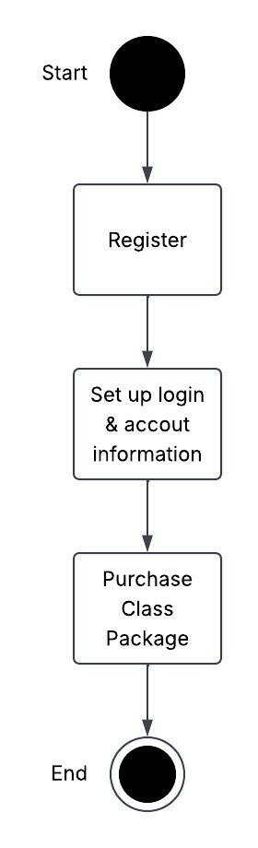

UML Sequence Diagram

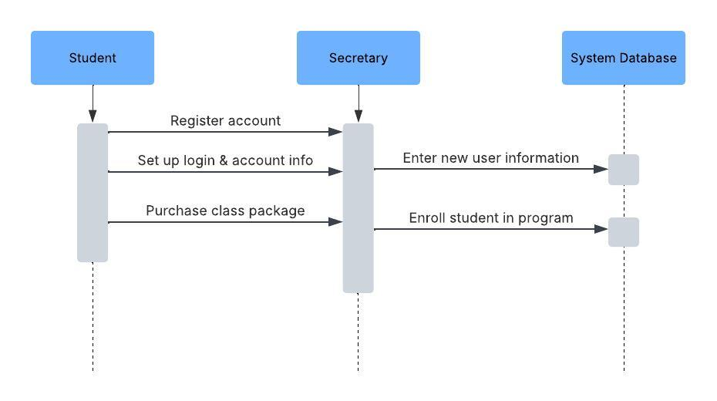

UML Class Diagram

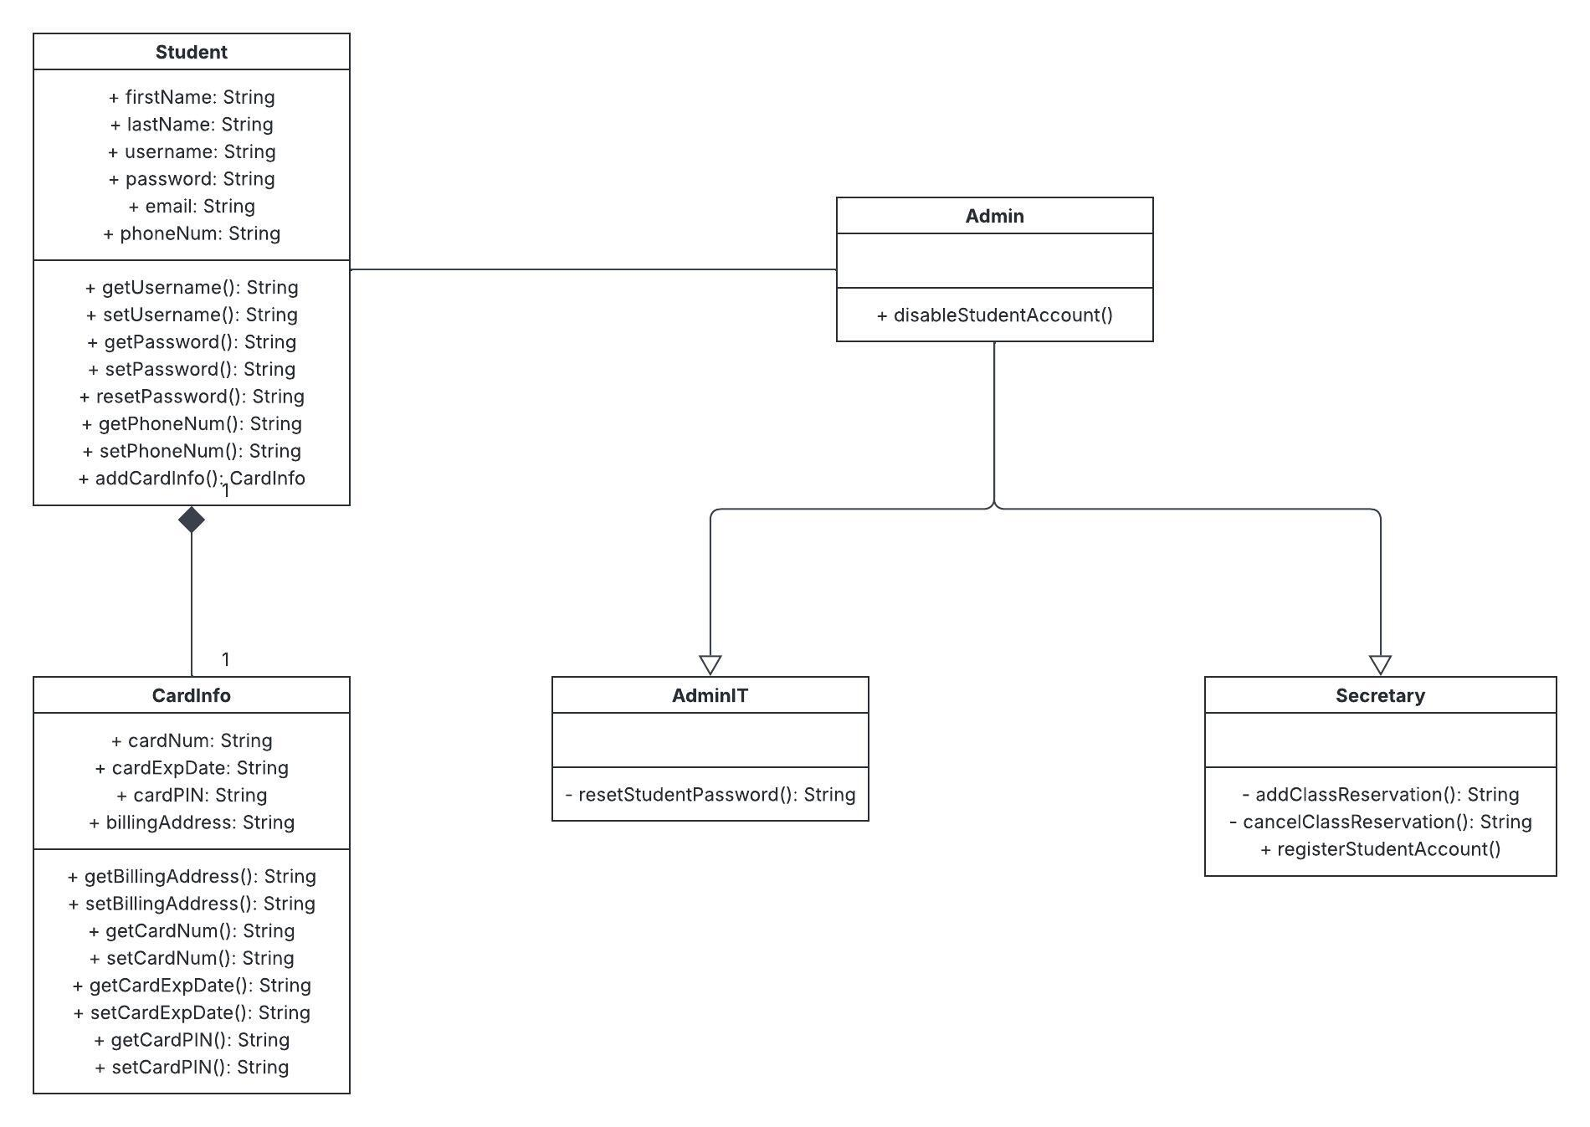

Technical Requirements

For hardware, the users should be able to access the system no matter what device they’re logging in from. The compatible devices should include any smartphones, tablets, and computers that have a web browser. DriverPass will also need access to a cloud system to handle data storage and additional security for the app.

For software and infrastructure, this system needs to be developed to be compatible with various browsers and device platforms and high-speed internet connectivity so that the users can use the app no matter what location and network they’re connected to. There also needs to be a way to authenticate the user’s login and other actions within the app. This way we can ensure valid users are accessing their own information and there aren’t any data or security leaks.

